**PROJECT DEVELOPMENT**

**PHASE SPRINT 1**

| **Date** | **05 November 2022** |
| --- | --- |
| **Team ID** | **PNT2022TMID13205** |
| **Project Name** | **Ai Based Discourse For Banking Industry** |

# **Create IBM Watson Assistant Service & Chatbot Skills**

* **Creation of IBM Watson Assistant Service:**

**To Implement Ai Based Discourse For Banking Industry, we need an IBM Service. The Service used in IBM WATSON ASSISTANT**

| **IBM SERVICE** | **WATSON ASSISTANT** |
| --- | --- |
| **REGION** | **DALLAS** |
| **LANGUAGE** | **ENGLISH** |

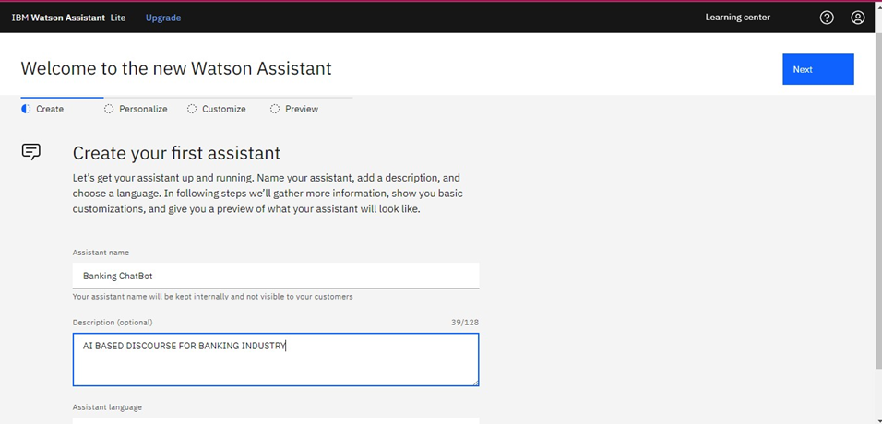

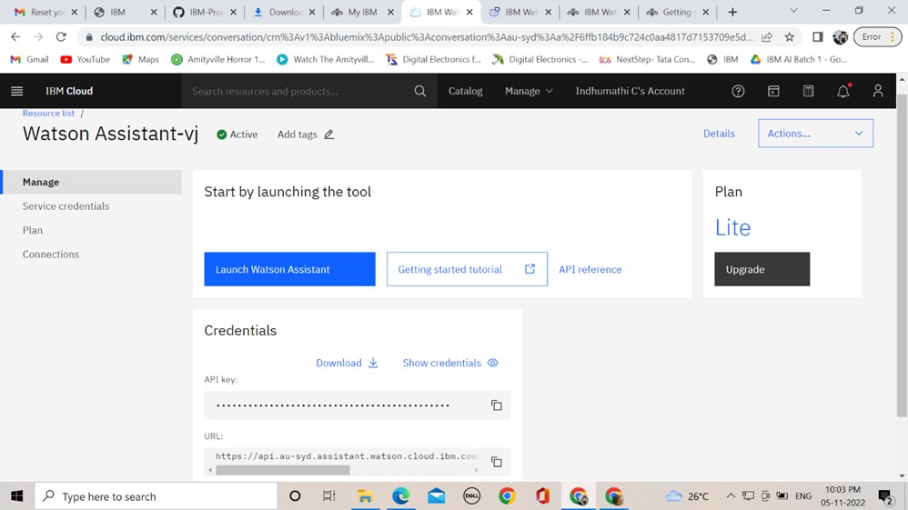

# **Creation of Chatbot Skills:**

**Skills are nothing but actions and steps. Steps are the subset of actions where conversations are built and Assistant is used to integrating skills.**

**The Chatbot build for the project AI Based Discourse for Banking Industry is based on ACTION SKILLS.**

| **SKILL TYPE** | **ACTION OR STEP SKILL** |
| --- | --- |
| **LANGUAGE** | **ENGLISH** |

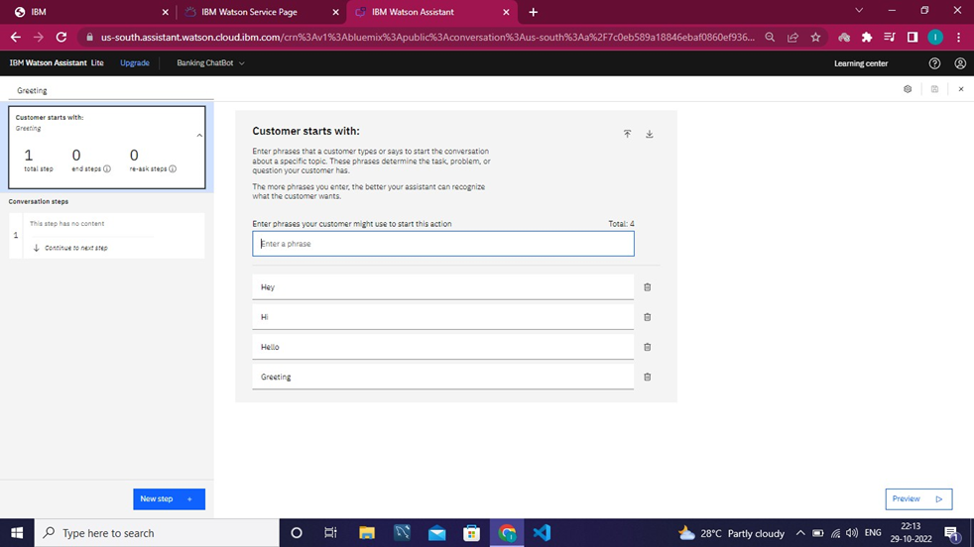

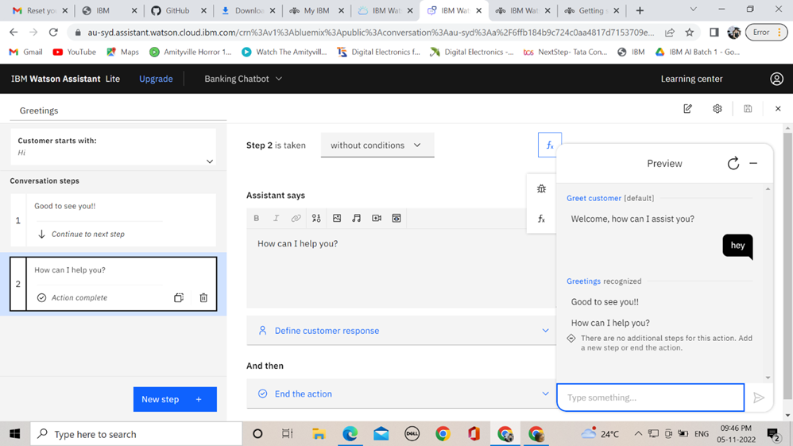

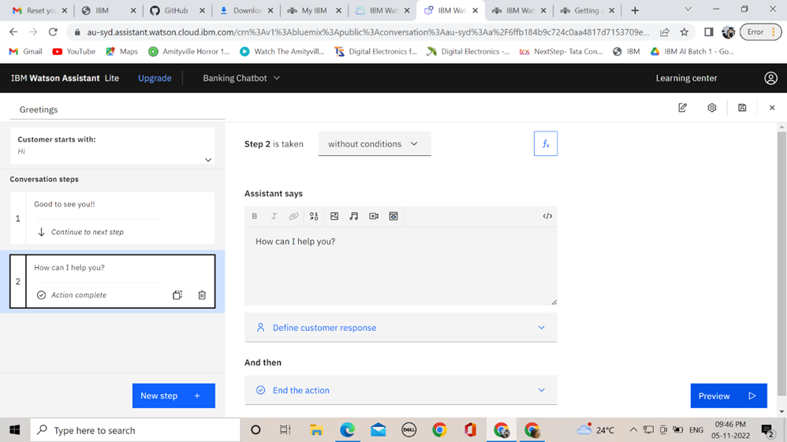

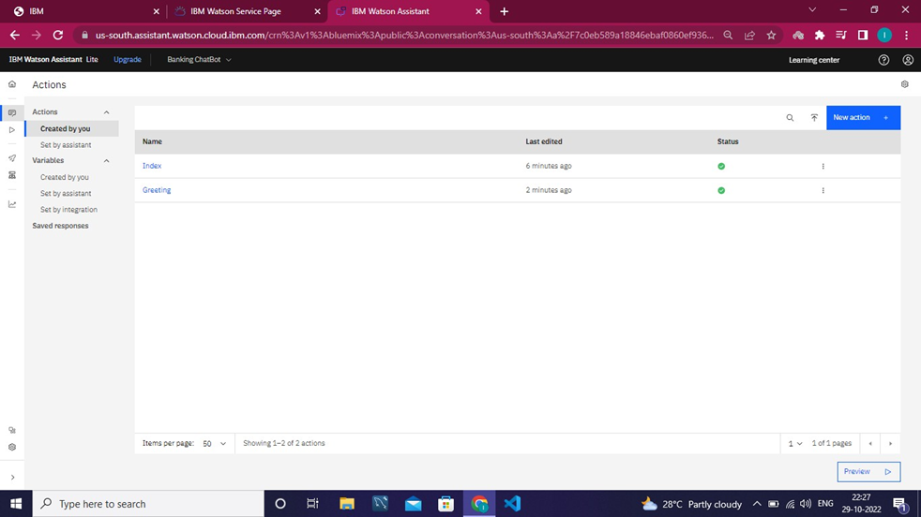

**Note: In this Sprint 1, there is no code needed to create assistant and skills, it purely based on Actions and steps**